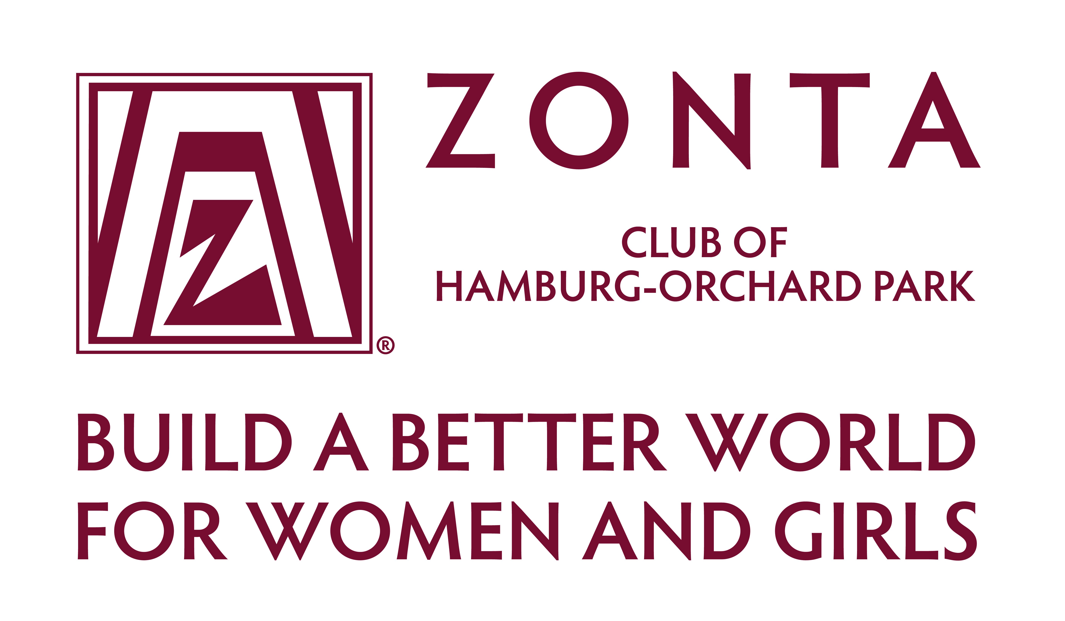

To: Development Office
From: Zonta Club of Hamburg-Orchard Park
Date: January 2025

Re: 2025 High School Scholarships

Enclosed is the scholarship application for our club’s annual award of $1000.00.

Although there is no one factor which determines who will win the award, some of the criteria we consider are scholastic achievement, leadership skills, community service and financial need.

Please feel free to duplicate the applications and distribute to any students you feel may be eligible.

Applications may also be accessed and completed via e-mail at
hamburgop@zontadistrict4.org or at our website: www.zontahamburgorchardpark.org.

Zonta International is a worldwide service organization working to “Build a Better World for Women and Girls”. The Zonta Club of Hamburg-Orchard Park has been chartered since 1966 and has been awarding scholarships almost since its inception.

Completed applications are due by April 1, 2025 and should be returned to:

Liz Newman
5246 Innesbrooke Court
Hamburg, NY 14075

Sincerely,
Judy Powers Scholarship Committee
Liz Newman dmlizzie@verizon.net; 716-649-5666

