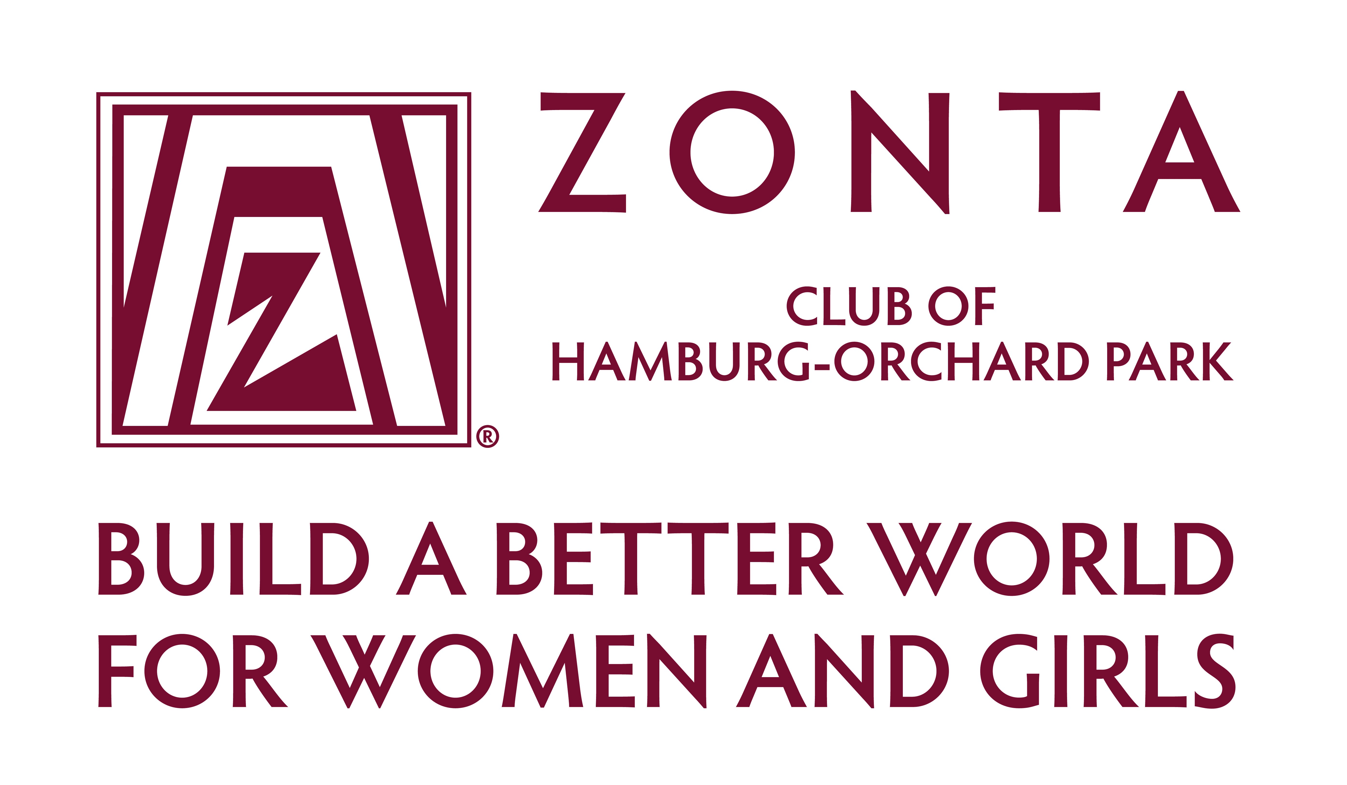

To: Development Office
From: Zonta Club of Hamburg / Orchard Park
Date: January 2025
Re: 2025 Zonta Adult Scholarship

Explanation of Purpose:
This $1,000 scholarship will be awarded to an adult woman desiring to pursue or complete her education to further her career or financial status.

Eligibility Requirements:

- Applicant must be a resident of the South Towns or attending school in the South Towns.

- Acceptance and proof of enrollment in an accredited school must be submitted before scholarship is awarded.

Selection Criteria:
- Satisfactory response to all segments of this application.

- Review of references

- All applications must be returned by student by April 1, 2025

- Selection Date: May 8, 2025

Applications may also be accessed and completed via e-mail at
hamburgop@zontadistrict4.org or at our website: www.zontahamburgorchardpark.org.

Zonta International is a worldwide service organization working to “Build a Better World for Women and Girls”. The Zonta Club of Hamburg-Orchard Park has been chartered since 1966 and has been awarding scholarships almost since its inception.

Contact person: Liz Newman - 716-649-5666
dmlizzie@verizon.net

Please feel free to duplicate the application as many times as necessary or request an on-line form at the above e-mail address. It is also available on our website: zontahamburgorchardpark.org under the Scholarship Tab.

