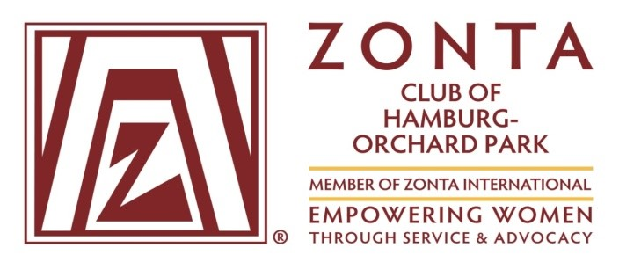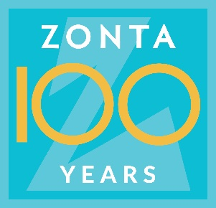
ZONTA CLUB OF HAMBURG- ORCHARD PARK
2021 ADULT SCHOLARSHIP APPLICATION Due: April 23, 2021

Name____________________________________________________________
First MI Last
Address __________________________________________________________
Street Town Zip
Phone __________________________ Cell ________________________
e-mail__________________________________ Marital Status S M D
Name and age of dependents ___________________________________________
___________________________________________
___________________________________________
Occupation __________________________________________________________
Employer ____________________________________________________________
Total annual household income (Include alimony, child support, etc.)
______________________________________________________________________
Post high school education ________________________________________________
Educational Plan: Name of Institution & Course of Study ______________________________________________________________________
______________________________________________________________________________
Are you currently enrolled? Yes _____ No _____
Type of Program: check one:
4 Year Degree _____ Associate Degree _____
Technical Certificate _____ Refresher Course _____ Other _______
List other scholarships and/or grants you will receive: _________________________________________________

Name: _________________________________________
Estimated cost per year for college education or program: _________________________
Amount of Student Loans you will require: $_________________________

List three references and include their place of business (eg. Teacher, employer).
Do not include relatives.
Name Place of Business Phone and position
1. _______________________________________________ _________________
2. _______________________________________________ _________________
3. _______________________________________________ _________________
State briefly in 150 words or less why you need this scholarship.
_____________________________________________________________________________________________

Please return this completed application by April 23, 2021 to:
Liz Newman
5246 Innesbrooke Court
Hamburg, NY 14075
716-649-5666 dmlizzie@verizon.net

