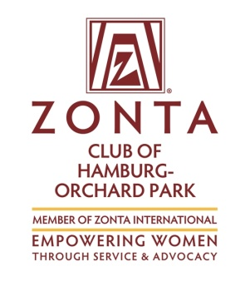
ZONTA OF HAMBURG-ORCHARD PARK
SCHOLARSHIP APPLICATION

2017 - 2018 School Year ( Confidential)
Due April 27, 2018

NAME________________________________________________________

Section to be completed by Guidance Office:
SCHOOL CURRENTLY ATTENDING___________________________
Average: ____________
HOMEROOM #_________ PHONE________________CELL_________
Rank:_______________
ADDRESS______________________________TOWN________________
GPA:________________
BIRTHDATE__________________e-mail_______________________Date of application______________

FAMILY INFORMATION:

Father’s Occupation:___________________________Employer:___________________________________

Mother’s Occupation:___________________________Employer:__________________________________

List the names and ages of siblings:

List persons currently living in your home (include siblings attending college)

Total Household Income:( (include child support,etc.) $__________________________ Annually

List any extenuating financial circumstances which the Committee should consider:

COLLEGE INFORMATION:

Which college do you plan to attend?_______________________________________________________
Which course do you plan to pursue?_______________________________________________________
Estimated cost per year for your college education: $_______________________________

List any other grants or scholarships you have received (include amounts):

____________________________________________________________________________________________

(over)

EMPLOYMENT INFORMATION:
List any work experience you have had (note your current employment, if any):

PERSONAL INFORMATION:
List school activities in which you have participated:

List sports in which you have participated:

List any community activities in which you have participated:

How have you demonstrated leadership qualities? (offices held, committee work, etc.)

In 150 words or less, write a paragraph explaining your interests, purpose for going to college, and your career goals: (You may add an extra sheet if necessary).

____________________________________________________________________________________________________________________________________________________________________________________________________________________________________________________________________________________________________________________________________________________________________________________________________________________________________________________________________________________________________________________________________________________________________________________________________________________________________________________________________________________________________________________________________________________________________________________________________________________________________________________________

DEADLINE: April 27, 2018
RETURN TO GUIDANCE OFFICE

